**Materials**

# The media use normally in the lab is 41965 - DMEM, high glucose

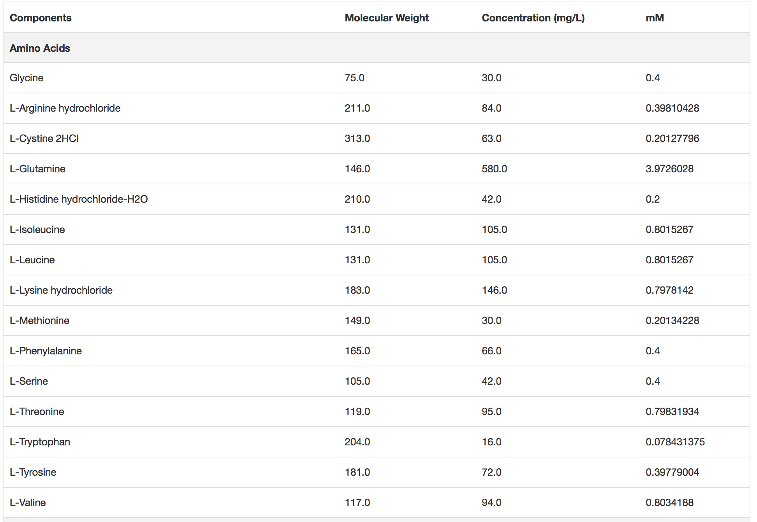

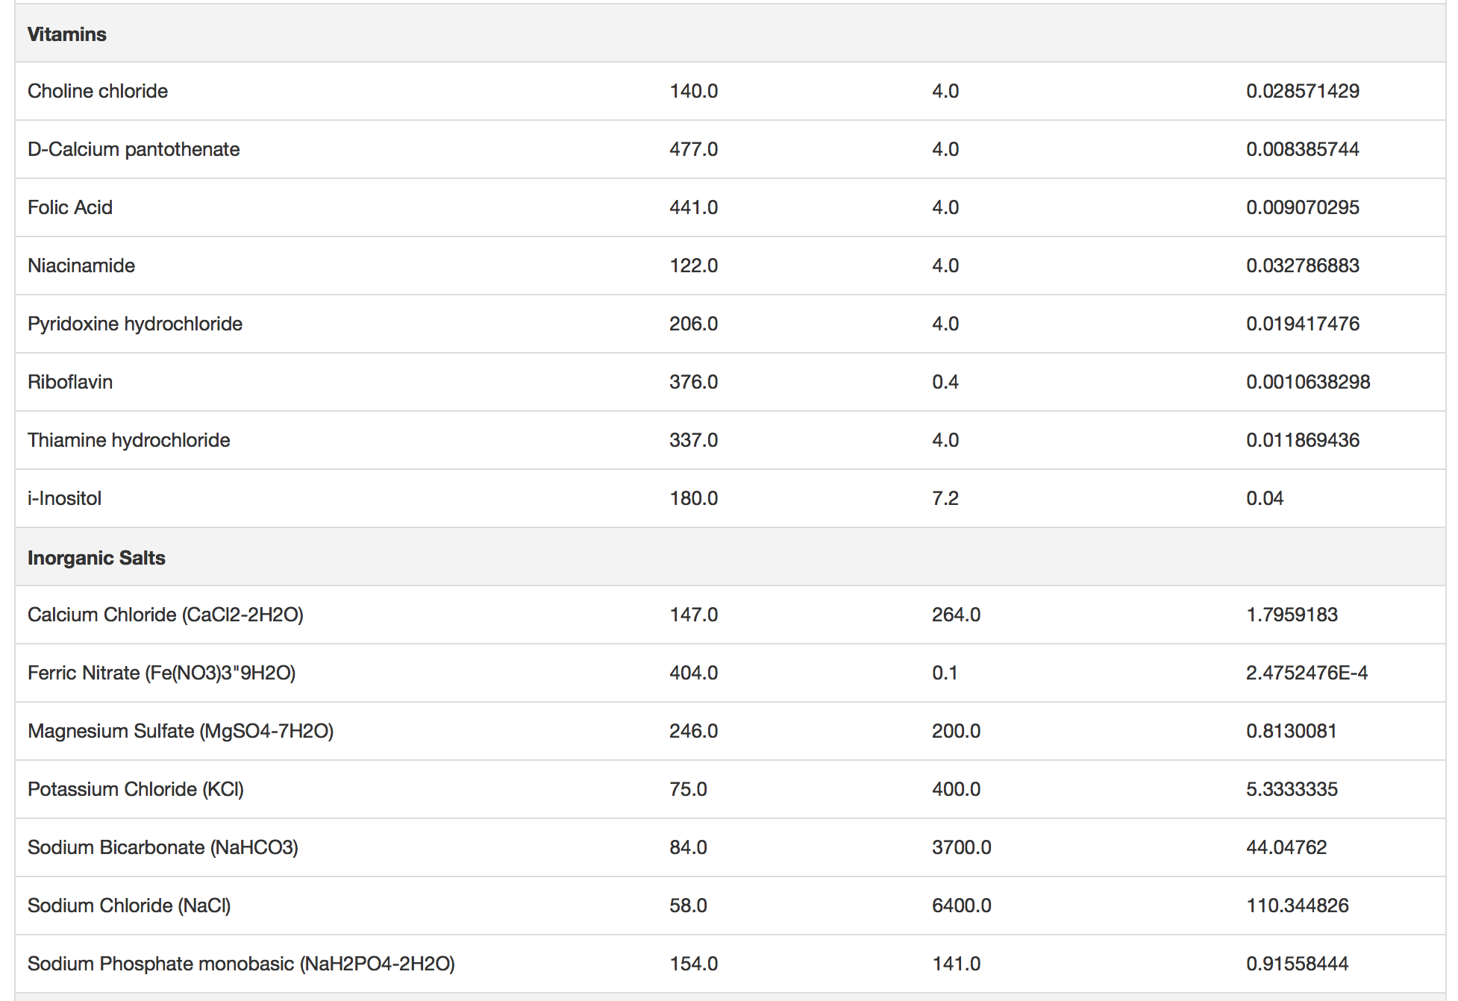

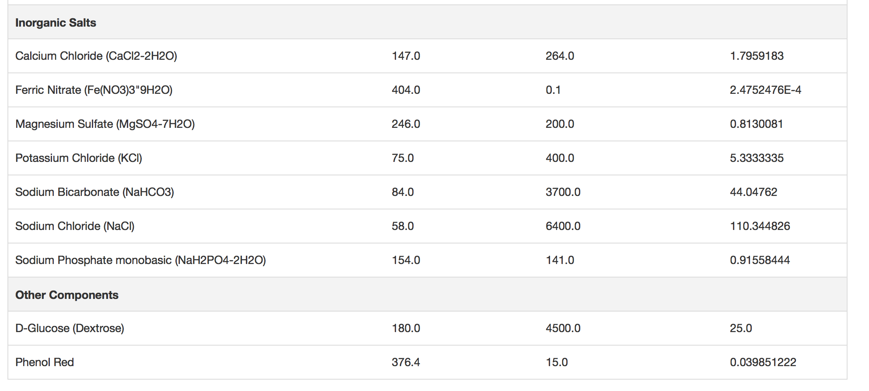

## 2)The media bought for the incubation was DMEM, no glucose, no glutamine, no phenol red **Catalog number:** A1443001

